ADScientific Index 2023
https://www.adscientificindex.com/compare/eskisehir-osmangazi-university-tr-2399/eskisehir-technical-university-tr-2400/
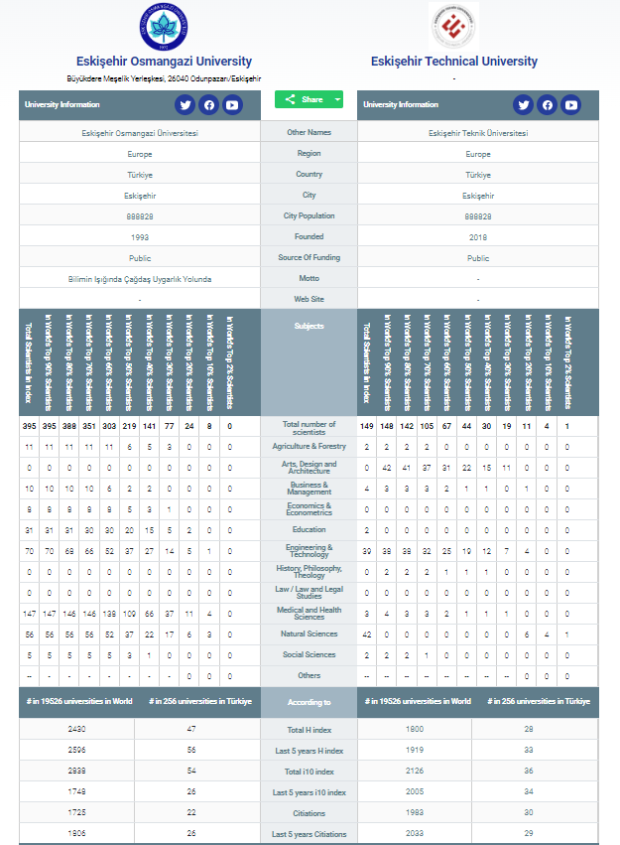
ADScientific Index 2023
https://www.adscientificindex.com/compare/eskisehir-osmangazi-university-tr-2399/eskisehir-technical-university-tr-2400/
