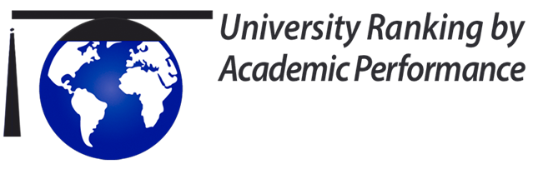
Anadolu Üniversitesi Eskişehir Osmangazi Üniversitesi Eskişehir Teknik Üniversitesi
(AÜ) (ESOGÜ) (ESTÜ)
Sıralama | Türkiye | Dünya | Türkiye | Dünya | Türkiye | Dünya
Webometrik, İspanya | 17/212 | 1283/31054 | 31/212 | 1718/31054 | 141/212 | 6855/31054
ODTÜ-URAP, Türkiye | 38/183 | 1837/3000 | 29/183 | 1557/3000 | 66/183 | 2607/3000
Times Higher Education,  İngiltere |  |  |  | 1000+
QS World University Ranking,  İngiltere |  | 1200-1400
CWUR, Birleşik Arap Emirliği | 42 | 1768/2000 | 44 | 1803/2000
USNEWS, ABD | 38 | 1600/2000 | 46 | 1718/2000
The Academic Ranking of World Universities (ARWU), Çin

Ranked Universities on Bachelors Portal, Hollanda
CWTS Leiden Ranking, Hollanda |  |  | 27 | 952

NTU Ranking,

Tayvan

RUR Ranking, Gürcistan
SCImago, İspanya | 15 | 672 | 26 | 691

ESOGÜ 12 Dünya 2021-2023 Üniversite sıralamasının yedisinde, Anadolu Üniversitesi altısında ve ESTÜ ise ikisinde yer almıştır.

https://www.webometrics.info/en/Europe/Turkey?page=1
https://urapcenter.org/Rankings/2022-2023/World_Ranking_2022-2023
https://www.timeshighereducation.com/world-university-rankings/2023/subject-ranking/engineering-and-it#!/page/1/length/25/locations/TUR/sort_by/rank/sort_order/asc/cols/stats
https://www.topuniversities.com/university-rankings/world-university-rankings/2023
https://cwur.org/2022-23.php
https://www.usnews.com/education/best-global-universities/eskisehir-osmangazi-university-529293
https://www.shanghairanking.com/rankings/arwu/2022
https://www.bachelorsportal.com/rankings/2/academic-ranking-of-world-universities-shanghai-jiao-tong-university.html
https://www.leidenranking.com/ranking/2022/list
http://nturanking.csti.tw/ranking/ByCountry/2022/TR
https://roundranking.com/country-rankings/countries-rankings.html#world-2021
https://www.scimagoir.com/rankings.php?country=TUR

BAZI SIRALAMA KURULUŞLARININ KRİTER ve AĞIRLIKLARI

Academic Ranking of World Universities (ARWU)
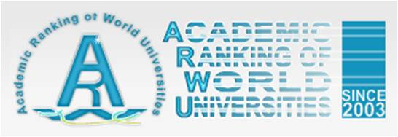
http://www.shanghairanking.com/
ARWU is an influential ranking list of world universities compiled by Shanghai Jiao Tong University (SJTU). Each year, the top 500 universities in the world are ranked based on a set of criteria:
Criteria | Indicator | Weight
Quality of Education | Alumni of an institution winning Nobel Prizes and Fields Medals | 10%
Quality of Faculty | Staff of an institution winning Nobel Prizes and Fields Medals  Highly cited researchers in 21 broad subject categories | 20%  20%
Research Output | Papers published in Nature and Science (not for institutions specialized in humanities and social sciences)  Papers indexed in Science Citation Index-expanded and Social Science Citation Index | 20%  20%
Per Capita Performance | Per capita academic performance of an institution | 10%
Total | - | 100%
From ARWU website: http://www.shanghairanking.com/methodology/arwu/2022

Times Higher Education (THE) World University Rankings
www.timeshighereducation.co.uk/world-university-rankings/
This is a ranking list compiled by UK Times Higher Education (THE). In 2010, THE split from its previous partner Quacquarelli Symonds and started to collaborate with Thomson Reuters to create a separate ranking list based on a new set of assessing criteria:
Criteria | Weight
Teaching - the learning environment | 30%
Research - volume, income and reputation | 30%
Citations - research influence | 30%
Industry income - innovation | 2.5%
International outlook - staff, students and research | 7.5%
From: https://www.timeshighereducation.com/world-university-rankings/methodology-world-university-rankings-2016-2017

QS World University Rankings
http://www.topuniversities.com/
This is a respected university ranking list published by Quacquarelli Symonds. The list was originally compiled in collaboration with Times Higher Education until 2010, when THE started to partner Thomson Reuters to create another list of ranking (see above).
400 world top universities are ranked every year based on six criteria:
Criteria | Weight
Academic reputation from Global Survey | 40%
Employer reputation from Global Survey | 10%
Citations per faculty from Scopus | 20%
Faculty student ratio | 20%
Proportion of international students | 5%
Proportion of international faculty | 5%
From: http://www.iu.qs.com/university-rankings/world-university-rankings/

Webometrics Ranking of World Universities
www.webometrics.info/

Also known as Ranking Web of World Universities, this ranking system developed by Cybermetrics Lab of the Spanish National Research Council (CSIC) evaluates universities in the world based on their web presence and activity. More than 20,000 universities around the world are covered.
Four criteria are used to obtain data for ranking:
Criteria | Weight
Size - Number of pages recovered from Google | 10%
Visibility - Number of external links received muliplied by the referring domains for these links | 50%
Rich Files - The following file formats are selected: Adobe Acrobat, Adobe PostSript, Microsoft Word and PowerPoint. | 10%
Scholar - Publishing data collected from Google Scholar and Scimago SIR | 30%
From: http://www.webometrics.info/en/Methodology

Prof. Dr. Muammer KAYA
ESOGÜ MMF DEKANI

